Knowledge Acquisition

The knowledge obtained for the assignment was mainly from the Aerospace Design and System Engineering Elements I course given in the first year of the Aerospace Engineering studies at TU Delft. The equations given in the course related most of the input parameters to the sizing of some aircraft elements such as the fuselage, the empennage, the wing and the propulsion system. Some of the equations include for example [1], [2]:

FUSELAGE DESIGN



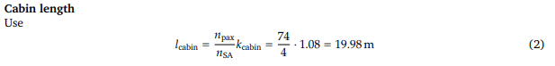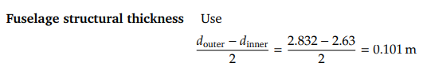

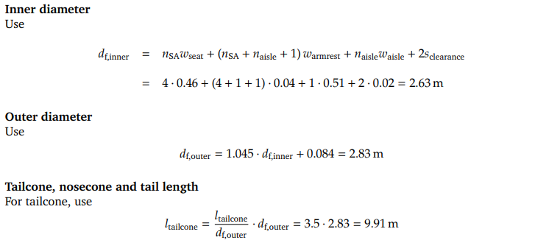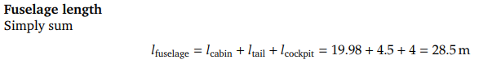

**Floor Postion**

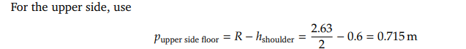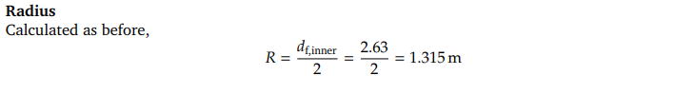

**Angles**

For the upper floor, use

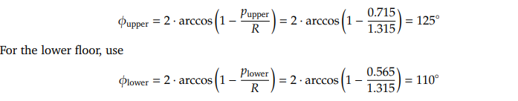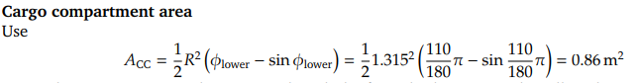

**Cargo compartment volume**

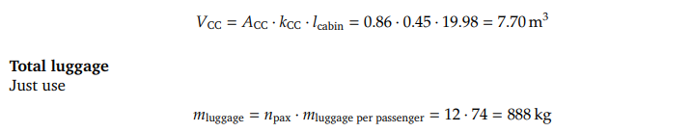

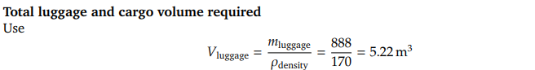

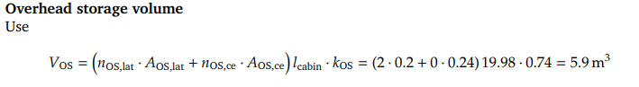

WING DESIGN

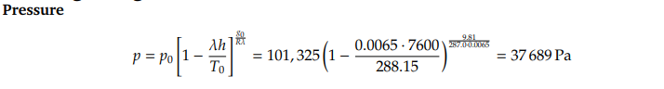

**Dynamic Pressure**



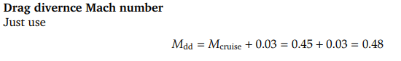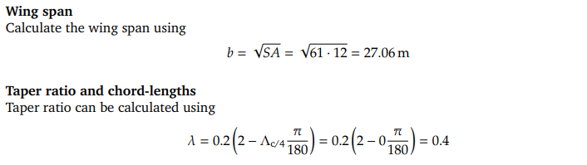

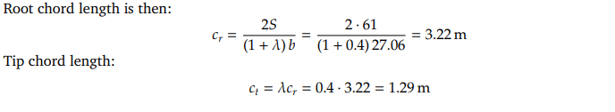

**Chord Sweep**





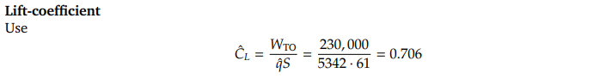

**Thickness-to-chord**

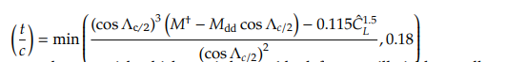

PROPULSION SYSTEM

**Diameter and Length of engine**

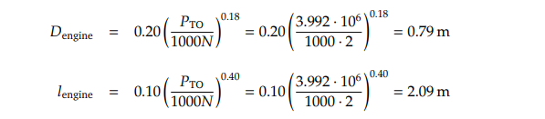

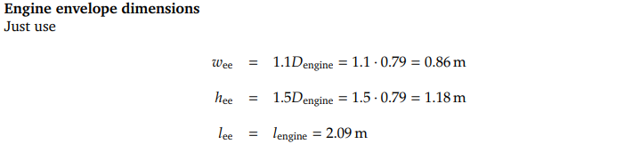

These equations at the same time come from the aircraft design books of Torenbeek [5] and Roskam [6].

For the center of Gravity Calculations:

To **size the tail**, next to the knowledge found on the ADSEE course slides some tail volume coefficients were found in [3].

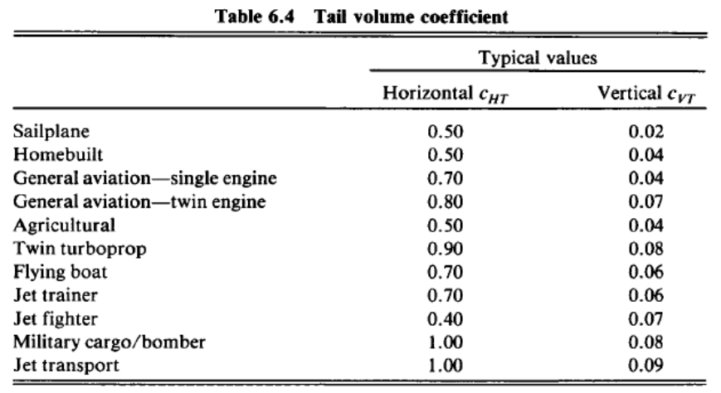

To calculate the **drag coefficient for the fuselage, empennage and engine nacelles**, reference [4] was used. It described how to get the drag coefficients for each of the components individually and it was then summed to the CD wing output of the Q3D.

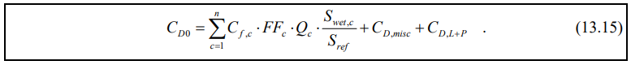

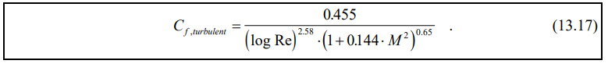

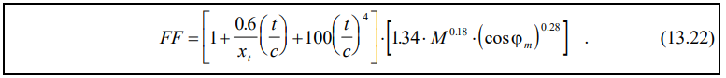

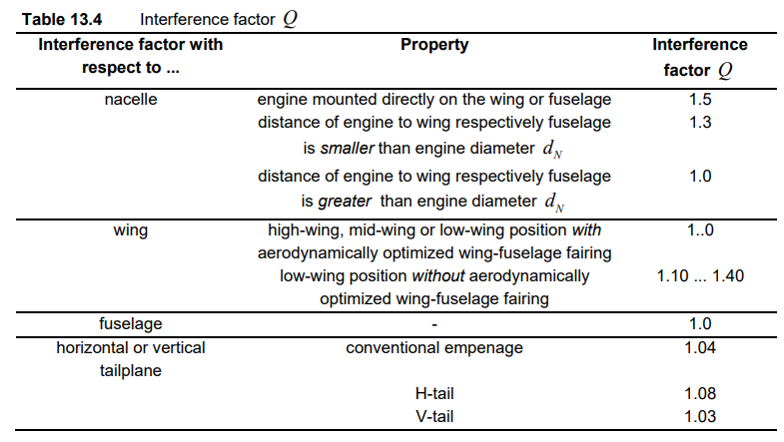

The Hydrogen calculations have used the following information from Liquid hydrogen. The information was obtained in [7].

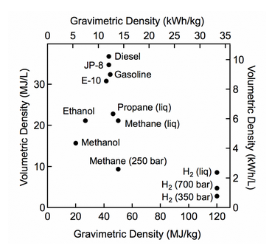

Bibliography

[1] *Data and formulae for aircraft preliminary weight estimation and sizing*. TU Delft, 1–2.

[2] (2016). *Exam Aerospace Design and System Engineering elements I , April 2016 1 . Aircraft Design Data sheet, April 2016,* TU Delft, 1–8.

[3] (n.d.). *Concept of Tail Volumes to size Horizontal and Vertical tails*. Gate Pathshala, 1-2.

[4] Scholz, D. (2018). *Drag Prediction*. Hamburg Open Online University, 1–16.

[5] Roskam,J. (1985) *Airplane Design: Preliminary sizing of Airplanes*. DARcorporation, 1-8

[6] Torenbeek, E. (1982). *Synthesis of Subsonic Airplane Design*. Delft: Delft University Press. ISBN: 9024727243

[7] (2020). *Hydrogen Storage: Hydrogen and Fuel Cell Technologies Office*. Energy.Gov, Web